

Vignette Solution Methods (VSM) Overview

Vignette Global Marketplace

Version 3.2

December 21, 2000

Trademarks
Vignette, the V logo, Vignette.com, StoryServer, Vignette Syndication Server, VSS Relationship Management For The Connected Customer, Vignette Server Agent, Vignette Professional Services, VPS, and Vignette Village are trademarks or registered trademarks of Vignette Corporation in the United States and other countries. All other referenced marks are those of their respective owners.
For questions, contact VSM@vignette.com
Printed on 12/21/2000 12:57:00 PM
Contact Vignette: 901 South Mo Pac Expressway, Building III, Austin, TX, 78746 or 512-306-4300.

Table of Contents
VSM Overview 1
Purpose and Scope 1
VSM Life Cycle 1
VSM Rapid Application Development (RAD) Approach 3
VSM Benefits 3
VSM Format 4
VSM Phases 4
Adapting VSM to a Specific Project 4
Phase 1: Discovery 5
Phase 2: Analysis 6
Phase 3: Design 7
Phase 4: Construction 7
Phase 5: Deployment 8
Phase 6: Support 8
Document Control 9
Change History 9
Document Storage 9
Document Owner 9

VSM Overview

Purpose and Scope
The Vignette® Solution Methods (VSM) is an implementation framework that helps Vignette customers, consultants, and partners develop Vignette e-business solutions as quickly and successfully as possible. Based on the collective experience of hundreds of successful Vignette Professional Services (VPS™) engagements, VSM uses flexible, repeatable methods and tools, and is continually improved by incorporating feedback from consultants and projects. (Note: VSM supercedes the Site Development Methodology.)

VSM covers the entire site development lifecycle from planning through operational deployment, with tasks that are adaptable to any type of project. VSM Phases and Tasks are linked to on-line documentation, guidelines and document stencils to provide you with a full set of methods and tools. These methods and tools accelerate the development process, maximize the return on investment, and reduce the risk of overlooking elements critical to the success of the project. VSM is about your success.

VSM Life Cycle
The VSM life cycle consists of six Phases, as shown in Figure 1. VSM Life Cycle. The VSM Phases section of this document provides detailed descriptions of Phases 1 (Discovery) through 6 (Deployment).

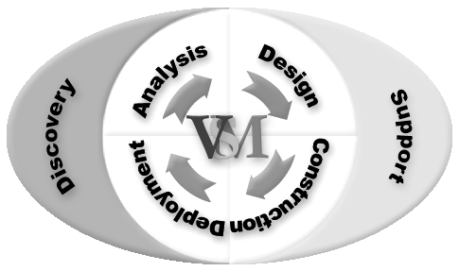
Figure 1. VSM Life Cycle
Each VSM Phase contains Tasks, output artifacts, associated roles, and supporting information and guidelines. Phase 1, Discovery is utilized at the start of a project to determine the initial scope and business objectives. Phases 2 through 5 form an iterative development process life cycle that can be used across product life cycle phases to produce phased deliverables. For example, if an initial prototype or proof-of-concept for the site needs to be developed prior to the first deployment, and the customer wants to add features in a release after the first release, the e-business product life cycle might look similar to the diagram below. The tasks and deliverables in the iterative releases would be tailored to the scope of the product deliverable for that release.
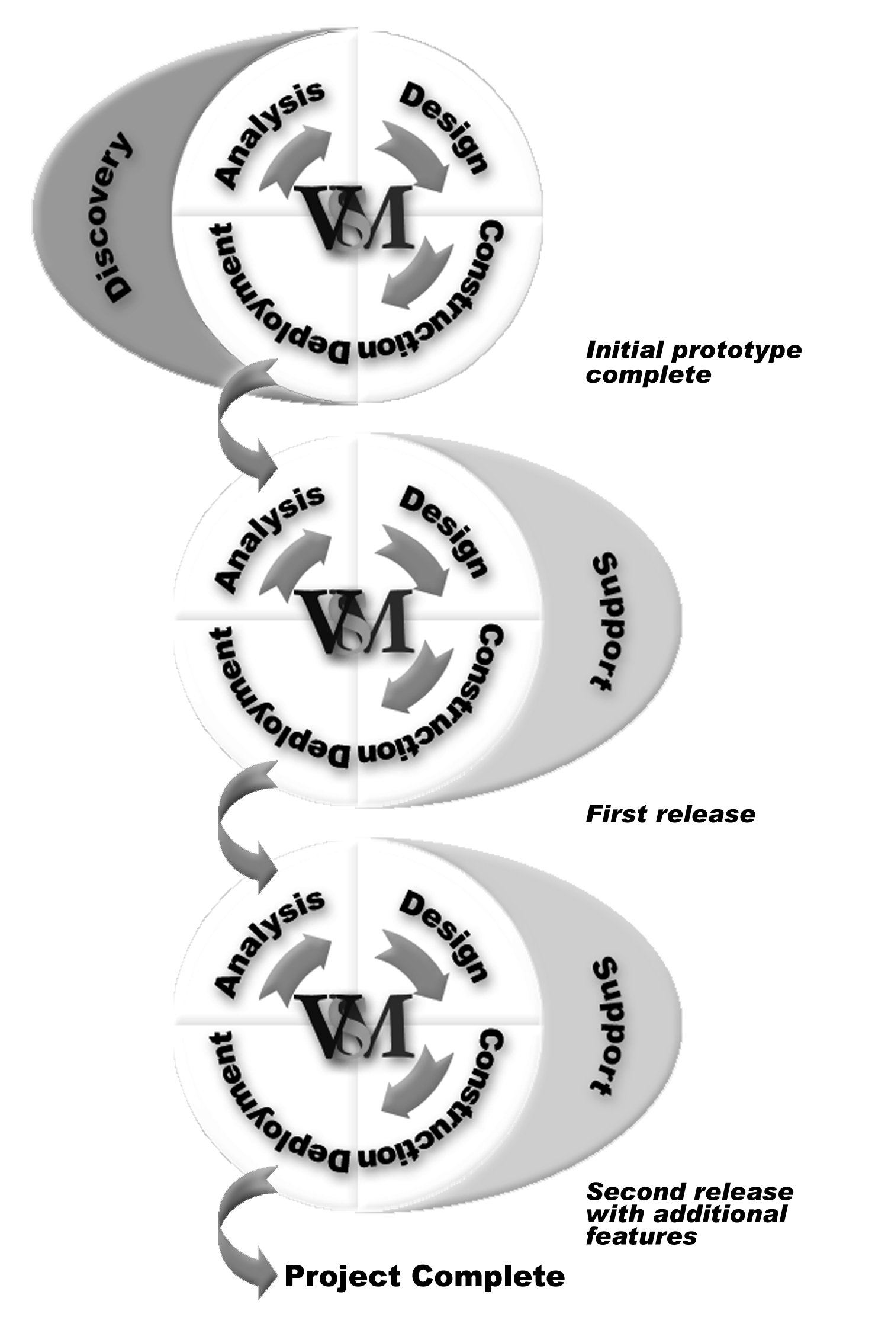
Figure 2. Example of VSM Life Cycle Iterations Within the Product Life Cycle

VSM Rapid Application Development (RAD) Approach
VSM can also be utilized within a Rapid Application Development (RAD) approach. RAD is a collection of practices that include requirements scrubbing and time-boxed development of a small set of features with intensive review by end users. The VSM Tasks can be applied within the RAD process, as shown in Figure 3.
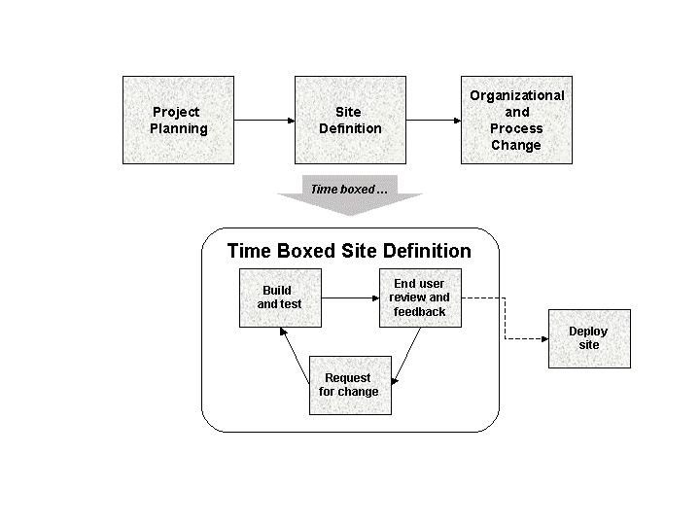
Figure 3. VSM RAD Process

VSM Benefits
VSM is based on Vignette Professional Services consultants’ extensive experience and learning during client engagements, and is designed to be a primary means of ensuring customer success.
Benefits of using VSM:
- VSM Phases and Tasks specifically support the deployment of Vignette’s products, and will evolve along with changes in Vignette’s product offerings.
- VSM’s iterative development process allows for rapid, staged deployment, with follow-on releases of additional features.
- VSM’s comprehensive set of tasks and guidelines reduce the risk of overlooking elements critical to the customer’s success.
- VSM uses reliable, repeatable methods and tools and reduces overall engagement risks.
- VSM integrates the use of key resources such as Vignette Global Marketplace, Vignette Solution Accelerators, and VPS Advanced Services offerings.
- VSM provides a basis for sharing and incorporating best practices and new methods to continually evolve and improve the state of our development practice.

VSM Format
VSM 3.0 Tasks are presented in Microsoft Project with hyperlinks to the VSM on-line documentation, which provides the following information for each Microsoft Project VSM Task:
Task description | A detailed description of the purpose of the Task and the activities involved in accomplishing it.
Primary role | The role with primary responsibility for accomplishing the Task. All roles are described in the VSM Team Model, a supporting document.
Supporting roles | Any additional roles involved in the Task.
Document stencil | The document stencil that can be used to create the output artifact for this Task. Document stencils contain prototypical outlines for the output artifacts, as well as providing guidance on the content for each section of the outline.
Input artifacts | Any previous project artifacts that are used in the process of completing this Task. (Artifacts are work products produced by the project, such as a project plan or a functional specification.)
Output artifacts | Any project artifacts that are generated as a result of the completion of this Task.
Supporting information | Any guidelines or white papers that can assist in the performance of this Task.

VSM Phases

Adapting VSM to a Specific Project
Each of the VSM Phases is summarized in the following tables. VSM includes a comprehensive set of tasks and artifacts which should be adapted or tailored to the scope and complexity of a specific project. VSM tailoring can include omitting tasks, or reducing the formality and complexity of a task or artifact. For example, a small short-term project would still create a requirements document, but it might consist of fewer pages and be less formal than a requirements document for a larger project.

Phase 1: Discovery
Purpose | To ensure that client information is transferred to the project team, establish the high-level goals and objectives, and assess the risks of the program. A program can encompass overall planning for several projects. At the project level, the purpose is to create and institute the necessary plans and procedures to ensure successful project execution.
Tasks Included | Gather and document client background information.
Tasks Included | Complete contractual negotiations.
Tasks Included | Perform preliminary effort and technical scoping.
Tasks Included | Define initial program plan, including roles and responsibilities, critical success factors, risks, and product and functionality commitments.
Tasks Included | Conduct Project Kickoff meeting to define project strategies for:  - Requirements change control  - Risk management plan  - Communications plan  - Issue resolution plan  - Project team roles and responsibilities
Output Artifacts | Contractual agreement with customer
Output Artifacts | Initial program and project management plans
Examples of Associated Document Stencils or Guidelines | Project Preparation Survey
Examples of Associated Document Stencils or Guidelines | Project Charter
Examples of Associated Document Stencils or Guidelines | Project Kickoff Worksheet
Examples of Associated Document Stencils or Guidelines | Project Management Plan
Completion Milestones | Signed contractual agreement
Completion Milestones | Completed initial program plan
Completion Milestones | Completed and approved initial project plan

Phase 2: Analysis
Purpose | To define and document the client’s overall business and application requirements. This Phase includes the definition of the organizational requirements for ongoing content management and maintenance of the client site, which is usually done in parallel with the development of the application requirements.
Tasks Included | Define the overall business requirements.
Tasks Included | Define site target audiences.
Tasks Included | Define workflow requirements.
Tasks Included | Define content display and content management requirements.
Tasks Included | Define content production, globalization, personalization, performance, e-commerce, and multi-channel requirements (can also be done through Advanced Services workshops).
Tasks Included | Define key performance indicators.
Tasks Included | Write requirements document.
Tasks Included | Begin requirements test plan.
Tasks Included | Define new organizational roles and responsibilities and e-business management processes.
Tasks Included | Define organizational change management approach.
Output Artifacts | Requirements document
Examples of Associated Document Stencils or Guidelines | Requirements document
Examples of Associated Document Stencils or Guidelines | Advanced Services Workshops for Content Management, Wireless, Personalization, Business Analytics, and Trading Partner Advantage
Examples of Associated Document Stencils or Guidelines | Questions for Gathering Client Requirements
Completion Milestones | Completed and approved Requirements document.

Phase 3: Design
Purpose | To design the Vignette solution that best satisfies the client’s business and technical requirements, and to define the underlying technology infrastructure needed to support the client application.
Tasks Included | Design workflow solution.
Tasks Included | Design Content Management application.
Tasks Included | Design Content Display application.
Tasks Included | Design database schema.
Tasks Included | Design cache management strategy.
Tasks Included | Define the network configuration.
Tasks Included | Develop the security strategy.
Tasks Included | Design staging strategy.
Tasks Included | Define the backup and recovery strategy.
Tasks Included | Conduct capacity planning.
Tasks Included | Provide detailed project plan and estimate to client.
Output Artifacts | Detailed project plan and estimate
Output Artifacts | Functional Specification
Output Artifacts | Detailed Design Specification
Output Artifacts | System Architecture Specification
Examples of Associated Document Stencils or Guidelines | Functional Specification
Examples of Associated Document Stencils or Guidelines | Detailed Design Specification
Examples of Associated Document Stencils or Guidelines | System Architecture Specification
Examples of Associated Document Stencils or Guidelines | Backup and Recovery Plan
Completion Milestones | Completed and approved functional specification
Completion Milestones | Completed system architecture specification
Completion Milestones | Completed and approved project plan and estimate

Phase 4: Construction
Purpose | Implement the client site based on the client’s requirements and the design. Perform component, functional specification, and requirements testing.
Tasks Included | Install software and defect tracking system. Set up development, test and production environments.
Tasks Included | Implement application architecture.
Tasks Included | Implement technical infrastructure architecture.
Tasks Included | Implement design specifications.
Tasks Included | Implement application integrations.
Tasks Included | Develop test plans.
Tasks Included | Perform component level testing.
Tasks Included | Perform functional specification and requirements testing.
Output Artifacts | Completed and tested application components and test plans
Examples of Associated Document Stencils or Guidelines | Template Development Guidelines
Examples of Associated Document Stencils or Guidelines | Code Review Guidelines
Examples of Associated Document Stencils or Guidelines | Test Plan and Test Scripts
Completion Milestones | Application and infrastructure components ready for beta testing and evaluation

Phase 5: Deployment
Purpose | Beta test and evaluate the site, launch the site, move site ownership to the supporting organization, and perform a project debriefing to gather lessons learned.
Tasks Included | Launch beta site and perform performance tests.
Tasks Included | Provide training and implement organizational changes.
Tasks Included | Launch the site.
Tasks Included | Transition ownership to the supporting organization.
Tasks Included | Perform project debriefing.
Output Artifacts | Completed system test documentation
Output Artifacts | Fully tested and launched site
Examples of Associated Document Stencils or Guidelines | Project Configuration Worksheet
Examples of Associated Document Stencils or Guidelines | Project Debriefing Worksheet
Examples of Associated Document Stencils or Guidelines | Site Submission and Promotion resources
Completion Criteria | Successful site beta test and launch based on predefined success criteria.

Phase 6: Support
The tasks for this Phase will be defined in a future version of VSM.
Appendix A: Acronyms and Definitions
Artifact A work product produced by the project, such as a completed document or completed application component.
Document stencil An outline or template that can be used to produce an artifact. The outline usually includes guidance regarding the intended content of the artifact.
VGM Vignette Global Marketplace, an on-line resource for customers, partners, and Vignette employees.
VPS Vignette Professional Services
VSA Vignette Solution Accelerators
VSM Vignette Solution Methods

Document Control

Change History
Revision | Release Date | Revised By | Description of Change
0.1 | 2/18/00 | Marsha Ellis | Initial/draft version for review
0.2 | 2/21/00 | Marsha Ellis | Revised based on VSP S&P reviews
1.0 | 2/24/00 | Marsha Ellis | Revised based on field input
1.1 | 2/28/00 | Marsha Ellis | Revisions from VPS S&P review
1.2 | 3/06/00 | Priya Hudson-DiTraglia | Fixed graphic; changed footers to comply with doc classifications
2.0 | 3/23/00 | Priya Hudson-DiTraglia | Updated based on 2.0 VSM and reformatted based on new VSM templates
3.1 | 5/25/00 | Marsha Ellis | Added document abstract. Changed name of VSM.
3.2 | 12/21/00 | Marsha Ellis | Updated for VSM 3.0.

Document Storage
This document was created using Microsoft Word 2000.

Document Owner
Marsha Ellis is responsible for developing and maintaining this document.

